**DOKUZ EYLUL UNIVERSITY**

**ENGINEERING FACULTY**

**DEPARTMENT OF COMPUTER ENGINEERING**

**CME1252 PROJECT BASED LEARNING – II**

**FINAL REPORT**

**PROJECT – I**

**Who Wants to Be a Millionaire**

**by**

**Gürkan Bıyık**

**Ahmet Salih Kara**

**Bedirhan Karaahmetli**

**Mehmet Mollaoğlu**

**Lecturers**

**Doc.Dr. Mehmet Hilal Özcanhan**

**Res.Asst. Fatih Dicle**

**IZMIR**

**17.03.2022**

# CHAPTER ONE

PROGRESS DESCRIPTION

Our project was Who Wants to Be a Millionaire. The aim of the project is to develop a software application for the "Who Wants to Be a Millionaire" competition. It is a quiz competition with contestants attempting to win a top prize of $1,000,000, by answering a series of five multiple-choice questions with increasing difficulty.

The questions are loaded from a text file. An automated spell-checking mechanism should be provided by the software. It should check each word in the question text by using the dictionary. The correction of the words must be suggested by the spell-checking mechanism; if there is a letter spelling error, or if two letters are reversed. After loading the file, the program has to give the following information: How many questions belong to each category? and How many questions belong to each difficulty level? Contestants try to correctly answer all the five consecutive multiple-choice questions and win the top prize. Contestants try to correctly answer all the five consecutive multiple-choice questions and win the top prize. If the contestant correctly answers all the five consecutive multiple-choice questions, the game is over, and he/she has won the top prize. If at any time the contestant gives a wrong answer, the game is over. Contestants giving an incorrect answer see their winnings drop down to the last tier milestone achieved. We started this project on February 21th 2022.

In first week, we discussed solution strategy and made a work sharing. We decided that we would both do our first week's tasks. Second week, we designed classes and data structures. In third week we coded competation operation commands and we coded lifelines operations.

And the last week we did statistics operations. We organised our code and gave its last shape. We added improvement. We make a powerpoint presentation and write final project report. We finished our project in March 17th 2022.

# CHAPTER TWO

TASK SUMMARY

## Completed Tasks

Gürkan Bıyık : I created a class that name is Question. We used this class while taking the questions from a text file. I completed word cloud and statics with Salih.

Ahmet Salih Kara : I did work cloud operations with using array,function and class. I calculated and printed statics. I worked with my friend Gürkan because Gürkan's computer broke down. I prepared a presentation.

Bedirhan Karaahmetli : The Contestants class was created and the functions that enable the contestants to be used were prepared. The game menu was designed and the design of the menu was prepared. The options in the game menu have been filled. It was ensured that the questions and competitors were removed from the file and the competition started. In the competition, the options were adjusted according to the answers given by the user, taking into account different situations.

Mehmet Mollaoğlu : An infobox was created in order to give players more information about the game itself. A wrapper was created for Enigma to make it more code friendly. A couple of visual procedures were created to make the player's experience more enjoyable. These procedures include a splash screen, a console paint function and an animated-looking printing function.

## Incomplete Tasks: Reasons and Explanations

Everything is completed successfully.

## Additional Improvements ~~to the Project~~

Visual improvements added to the game.

Randomized (Every game offers unique experience with randomized visuals and questions)

Totaly scalable and modifiable code

# CHAPTER THREE

EXPLANATION of algorıthms

## Screenshots

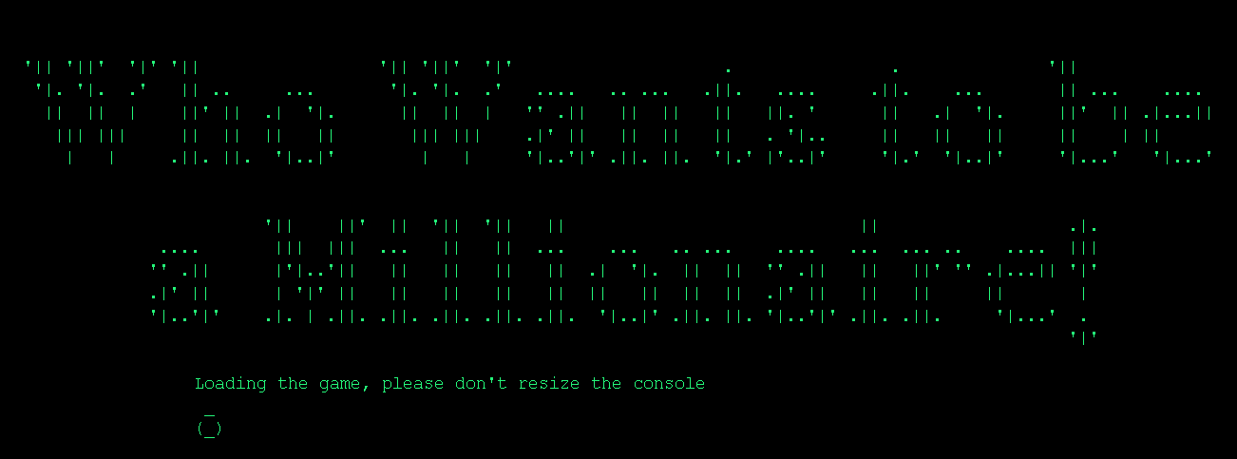

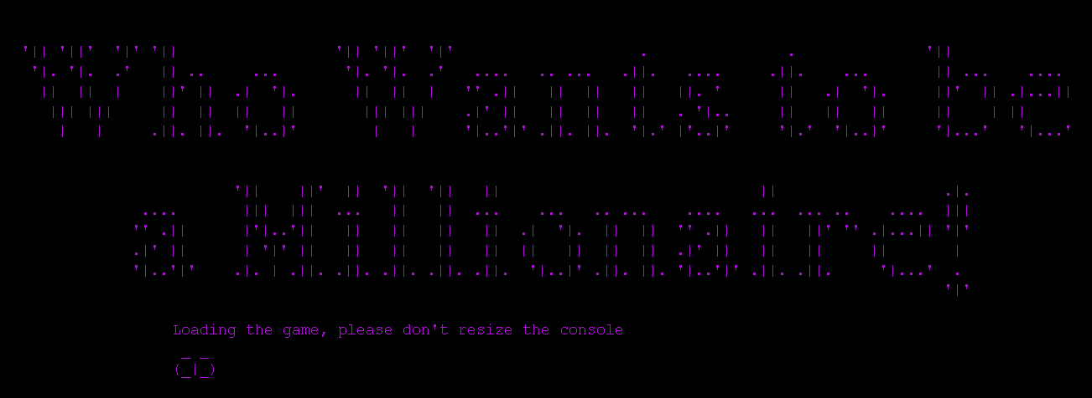

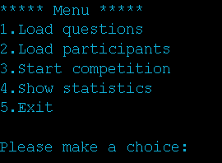



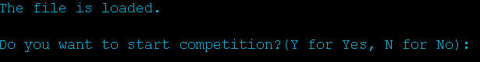

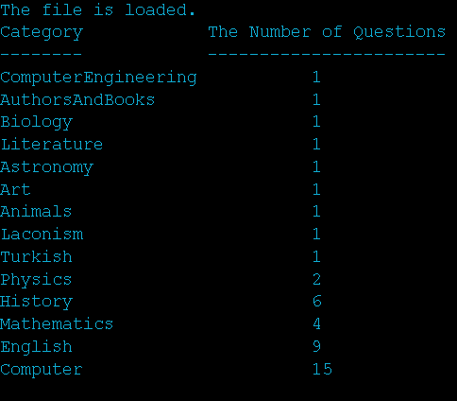

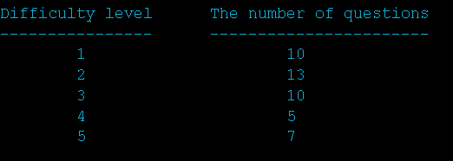

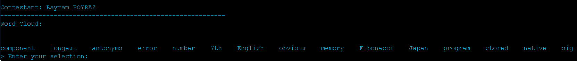

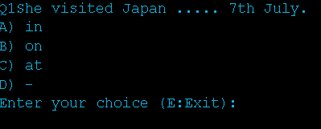

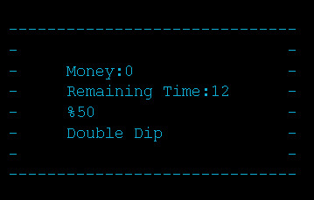

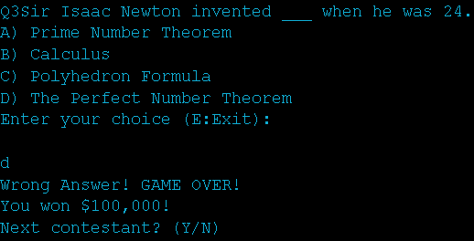



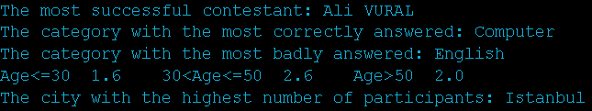

## Functions

public static boolean isStringInArray(String word, String[] words), public static boolean isDigitOrLetter(char chr), public static String insertCharIntoString(String str,String chr,int index), public static String[] spellChecker(String[] dictionary, String[] q_words), public static int randomInt(int min, int max) , public static Participant[] get_participants(String participant_txt), public static Question[] get_questions(String stop_word_txt, String question_txt), public static int get_question_id(int Difficulty, String key_word,Question[] questions), public static String[] generate_word_cloud(int Difficulty, Question[] questions), public static int getIndexOfArray(String word,String[] array), public static void print_statics(String[] statics, Question[] questions, Participant[] participants), public static String[] arrayCreater(String file_name), public static String[][] arrayDismantler(String[] array_1d), public static String[][] arrayDismantler(String file_name), public static void writeToFile(String file_name, String text), public void clearConsole(), public void consoleColor(int r, int g, int b), public void consoleColor(int r1, int g1, int b1, int r2, int g2, int b2), public void consoleColor(Color color1, Color color2), public void printInColor(Color color, String text), public void encodeWriting(String text), public static int compress(double value), public static int[] hueCube(double degree, int r, int g, int b), public void splashScreen(), public InfoBox(Console cn), public void run(), public void setIs50Used(boolean is50used), public boolean getIs50Used(), public void setIsDoubleDipUsed(boolean isdoubledipused), public boolean getIsDoubleDipUsed(), public void setThreadInterrupt(boolean thread_interrupt), public boolean getThreadInterrupt(), public void setIsTimeRunOut(boolean is_time_run_out), public boolean getIsTimeRunOut()

## Algorithms and Solution Strategies

Gürkan Bıyık : I created a random function, in operator function. Those functions helped me to avoid code duplication while assigning questions and calculating the statics. I created the Question class to use a minimal number of variables.

Ahmet Salih Kara : First of all, we shared the tasks. I researched my tasks and drew a path for myself. After that, I started to form the program gradually. I created the necessary variables and structures. I did work cloud operations with using array,function and class. I calculated and printed statics. I worked with Gürkan because Gürkan's computer broke down. When I encountered problems, I got help from my project friend. We found solutions by helping each other and we solved them.

Bedirhan Karaahmetli : The 'switch case' structure was used for the design and functionality of the menu and options. The 'while' structure was used to ensure the continuity of the competition.

Mehmet Mollaoğlu : A multithreading system had to be used in order to display a timer while taking the player's input. A console clear function was created using Enigma Wrapper to make the game screen has the fewest amount of distraction available. An imaginary cube was created using the Red, Blue and Red colours as dimensions. This cube was rotated in small amounts every iteration to achieve a smooth transaction between the colours.

# CHAPTER FOUR

PROBLEMS ENCOUNTERED

Gürkan Bıyık : My computer broke down. I did my duties with Salih. Some functions were not in java. So, I created the functions that do not exist in java.

Ahmet Salih Kara : I had a hard time reading and writing class because I encountered the Class structure for the first time.

Bedirhan Karaahmetli : When trying to print the number of questions in the categories on the screen, it did not appear properly due to the different lengths in the category names. Solved using the 'for' loop and considering the length of the category names.

Mehmet Mollaoğlu : We didn't have much information about enigma library at first. We had to extract the jar file and examine the classes. A wrapper library was created in order to makenit easier to use.

# CHAPTER FIVE

Conclusıon

While developing this project, We met on discord and helped each other code. We have learned , making algorithms, team work and managing time. We have learned usage of class and object. We gained analytical thinking skills and problem-solving ability. It’s a great learning process for us.

REFERENCES

<https://stackoverflow.com/>

<https://www.geeksforgeeks.org/>

<https://www.javatpoint.com/>

<https://www.w3schools.com/>

https://github.com/mikepound/enigma

**AppendIx**

Code of the Project

